Practical no. 7
Name :- Danish Altaf Solkar Enrolment no. :-24111590805
Class :- CO3K – B Subject :- DMS
Aim:- Implement queries using Aggregate functions

QUERY :- SELECT * FROM co;
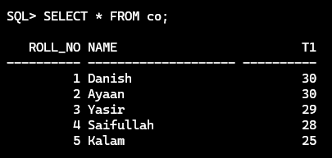

QUERY :- ALTER TABLE co ADD t2 NUMBER;
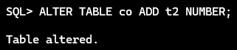

QUERY :- UPDATE co SET t2 = t1-2;
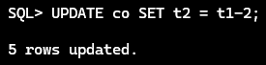

QUERY :- ALTER TABLE co ADD total NUMBER;
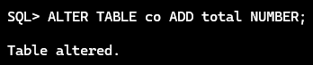

QUERY :- UPDATE co SET total = t1 + t2;
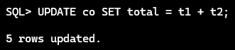

QUERY :- ALTER TABLE co ADD avg NUMBER;
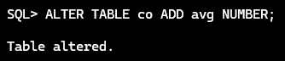

QUERY :- UPDATE co SET avg = (total / 2);
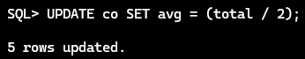

QUERY :- ALTER TABLE co ADD percent NUMBER;
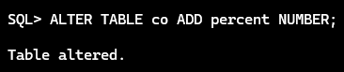

QUERY :- UPDATE co SET percent = (total / 60)* 100;
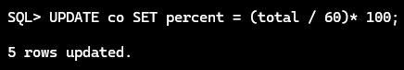

QUERY :- SELECT * FROM co;
